Book

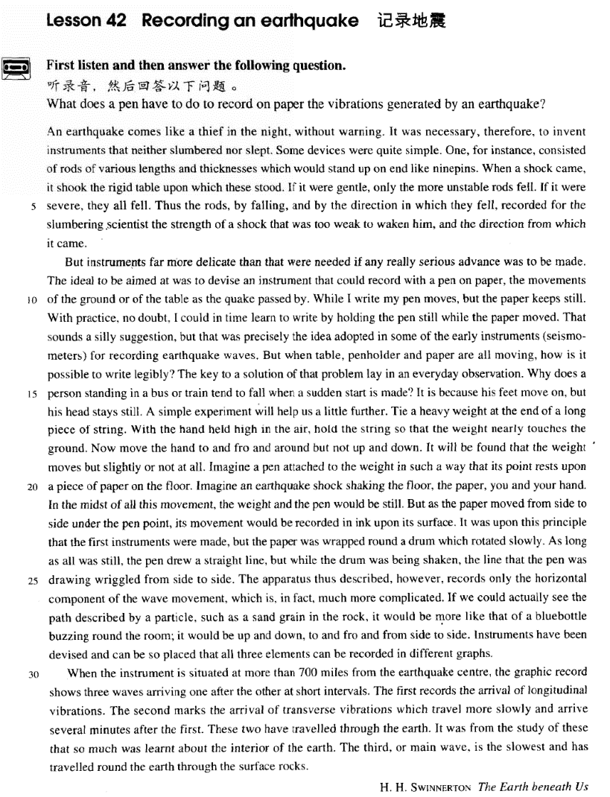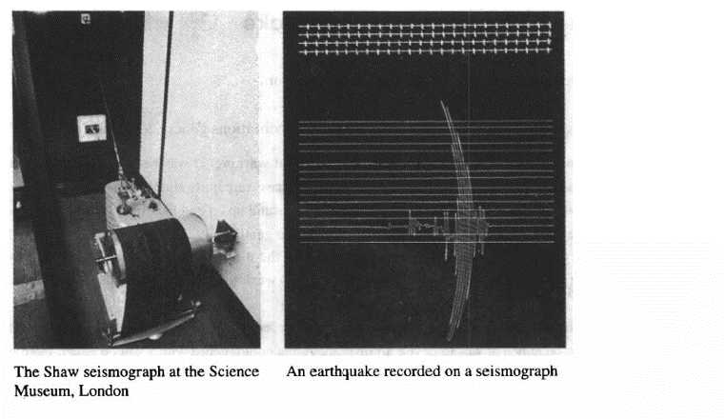

课文

An earthquake comes like a thief in the night, without warning.

地震就像夜间的小偷，不打招呼就来了。

It was necessary, therefore, to invent instruments that neither slumbered nor slept.

因此，有必要发明一种仪器，既不打盹儿，也不睡觉。

Some devices were quite simple.

有些装置非常简单。

One, for instance, consisted of rods of various lengths and thicknesses which would stand up on end like ninepins.

例如，有一种装置是由一些长短、粗细不同的木棒组成，就像九柱戏的木棒一样坚立着，

When a shock came, it shook the rigid table upon which these stood.

一旦有地震，就会震动竖立在坚硬的桌上的木棒。

If it were gentle, only the more unstable rods fell.

如果地震轻微，只有不稳定的木棒倒下；

If it were severe, they all fell.

如果地震剧烈，所有的木棒都会例下。

Thus the rods, by falling, and by the direction in which they fell, recorded for the slumbering scientist the strength of a shock that was too weak to waken him, and the direction from which it came.

由于地震太弱而未惊醒科学家时，木棒倒下的多少和倒下的方向就为科学家记录下了地震的强度和地震方向。

But instruments far more delicate than that were needed if any really serious advance was to be made.

但是，如果要取得真正重大的进展，需要有比这种装置精细得多的仪器。

The ideal to be aimed at was to devise an instrument that could record with a pen on paper, the movements of the ground or of the table as the quake passed by.

理想的目标是设计出这样一种仪器：当地震发生时，它能用笔在纸上记录下大地和桌子运动情况。

While I write my pen moves, but the paper keeps still.

我写字时，笔是移动的，纸是静止的。

With practice, no doubt, I could in time learn to write by holding the pen still while the paper moved.

毫无疑问，经过练习，我最终能够学会笔不动而纸动来写字。

That sounds a silly suggestion,

这听起来似乎是一种愚蠢的想法，

but that was precisely the idea adopted in some of the early instruments (seismometers) for recording earthquake waves.

但是早期记录地震波的仪器（地震仪）正是采用了这中思路。

But when table, penholder and paper are all moving, how is it possible to write legibly?

可是，当桌子、夹笔装置、纸都在移动时，怎么能书写得清楚呢？

The key to a solution of that problem lay in an everyday observation.

可以从我们的日常生活观察中找到这个问题的答案。

Why does a person standing in a bus or train tend to fall when a sudden start is made?

一个人站在公共汽车或火车上，当车突然开动时，他为什么会倾倒呢？

It is because his feet move on, but his head stays still.

这是因为他的脚动了，而他的头保持着静止。

A simple experiment will help us a little further.

再做一个简单的实验可以帮助我们进一步理解这个问题。

Tie a heavy weight at the end of a long piece of string.

把一个重物拴在一根长绳子的一端，

With the hand held high in the air, hold the string so that the weight nearly touches the ground.

把手高高举在空中握住绳子，让重物几乎接触地面。

Now move the hand to and fro and around but not up and down.

然后把手前后左右以及旋转摆动，但不要上下摆动。

It will be found that the weight moves but slightly or not at all.

结果会发现，重物是动了，但动得很小，甚至没动。

Imagine a pen attached to the weight in such a way that its point rests upon a piece of paper on the floor. Imagine an earthquake shock shaking the floor, the paper, you and your hand.

假定地震发生了，地板、纸、你和你的手都会动，在这些所有的运动中，重物和笔却不动。

In the midst of all this movement, the weight and the pen would be still. But as the paper moved from side to side under the pen point, its movement would be recorded in ink upon its surface. It was upon this principle that the first instruments were made, but the paper was wrapped round a drum which rotated slowly.

由于纸在笔下来回运动，纸的表面就会用墨水记录下地板运动的情况。根据这一原理，制造出了最初的地震仪器，但是纸是卷在慢慢放置的圆筒上的。只要一切都是静止的，笔就会划出一条直线；

As long as all was still, the pen drew a straight line, but while the drum was being shaken, the line that the pen was drawing wriggled from side to side. The apparatus thus described, however, records only the horizontal component of the wave movement, which is, in fact, much more complicated.

但是，圆筒受到震动，笔所画出的线就会就会左右摆动。假如我们真能看到诸如岩石中一个沙粒子的运动轨迹，

If we could actually see the path described by a particle, such as a sand grain in the rock, it would be more like that of a bluebottle buzzing round the room; it would be up and down, to and fro and from side to side.

那就像一只嗡嗡叫的绿头苍蝇在屋内飞行的轨迹，呈现出上上下下、来来回回、左左右右3种性质的运动。

Instruments have been devised and can be so placed that all three elements can be recorded in different graphs.

经设计出了一些仪器，它按照一定的安放方式就可测绘出这三种运动的曲线图。

When the instrument is situated at more than 700 miles from the earthquake centre,

如果把这种仪器安装在距震源700多英里远的地方，

the graphic record shows three waves arriving one after the other at short intervals. The first records the arrival of longitudinal vibrations.

曲线记录就能显示出前后相同的这3种地震波。首先记录下的是纵向波的到达；

The second marks the arrival of transverse vibrations which travel more slowly and arrive several minutes after the first.

然后记录下的是横向波的到达，横向波比纵向波传播得慢，在纵向波到过几分钟后能到达。

These two have travelled through the earth.

这两种波都是穿过地球而来的。

It was from the study of these that so much was learnt about the interior of the earth.

正是从这两种波中的研究中，我们可以了解到地球内部的许多情况。

The third, or main wave is the slowest and has travelled round the earth through the surface rocks.

第三种波，即主波，是最慢的，是围绕地球通过表面岩石传来的。

词汇讲解

Lesson 42 Recording an earthquake

rigid ['rɪdʒɪd]

adj. 坚硬的，刚性的，僵化的，固执的

rigid adj. stiff or fixed, not able to be bent, moved, changed or persuaded

坚硬的，刚性的，僵化的，固执的

rigid plastic containers

Several colleges in our study have rigid rules about student conduct. rigid adherence to old-fashioned ideas

rigidity n. [U] 坚硬，刚性，僵化，固执

the rigidity of the metal bar

the rigidity of the law on this issue

flexible adj. 易弯曲的，柔韧的，可变通的，灵活的

shoes with flexible rubber soles

A gymnast has to be flexible above all else. Our plans are quite flexible.

Accountancy can offer flexible working hours. flexibility n. [U] 柔韧性，灵活性

exercises to develop the flexibility of dancers' bodies

Employees expect flexibility in the workplace. delicate ['delɪkət]

adj. 精密的，灵敏的

delicate adj. 1. able to measure very small changes 精密的，灵敏的Weather-forecasters have extremely delicate equipment which helps them predict what the weather is going to be like.

But instruments far more delicate than that were needed if any really serious advance was to be made.

delicate adj. 2.（颜色、气味、味道）淡的，柔和的

delicate fragrance

Despite the fact that the bottle is tinted a delicate shade of green, an observant visitor would soon notice that it is filled with what looks like a

thick greyish substance.

delicate adj. 3. 细致的，娇嫩的；易损坏的；需谨慎处理的

her delicate features a baby's delicate skin

delicate china teacups a delicate problem

The delicate surgical operation took 5 hours. delicacy n. 1. [U] 精致，细致，娇嫩；谨慎处理the delicacy of carving

the delicacy of her features the delicacy of a child's skin

She handled the situation with great sensitivity and delicacy. delicacy n. [C] 美味佳肴

If you lived in the Mediterranean, for instance, you would consider

octopus a great delicacy. seismometer [saɪz'mɒmɪtə]

n. 地震仪

“meter” / “metr” = measure

seismometer “seismo” = shake n. 地震仪

meter n. 仪器，仪表；米，公尺；v. 测量

metric adj. 米的；公制的

diameter “dia” = across n. 直径

thermometer “thermo” = heat n. 温度表，体温表

barometer “baro” = weight n. 气压计voltmeter “volt” = 伏特 n. 电压表speedometer “speed” = 速度 n. 速度表milometer “mil” =mile n. 里程表hygrometer “hygro” = wet n. 湿度计perimeter “peri” = round n. 周长geometry “geo” = earth n. 几何学symmetry “sym” = together n. 对称wriggle ['rɪgl]

v. 扭动，蠕动；扭动前进

wriggle v. 1. to twist your body, or move part of your body, with small, quick movements 扭动，蠕动

A large worm wriggled in the freshly dug earth.

Baby Martha was wriggling her toes in the sand.

wriggle v. 2. to move somewhere using short, quick twisting movements

扭动前进

The tunnel was low and dark, but she managed to wriggle through to the

other side. wiggle v. 扭动

She wiggled her toes in the water.

Her hips wiggle as she walks. waggle v. 扭动

His bottom waggles in a funny way when he walks.

She can waggle her ears. wag v. 摆动

The dog's tail wagged.

The dog wagged its tail excitedly.

"You shouldn't have done that!" Mum said, wagging her finger at me. longitudinal

[7lɒŋgɪ'tju:dɪnl]

adj. 纵向的

longitudinal adj. going from the top to the bottom of sth. 纵向的

the longitudinal axis longitudinal stripes

a longitudinal section “long” = long（长的）

longevity “ev” = time n. 长寿

longitude “itude”（抽象名词字尾）n. 经度

longitudinal adj. 纵向的

elongate “e” = out v. 使变长，拉长

elongation n. 拉长，延长

prolong “pro” = forward v. 延长时间prolonged adj. 长期的，持久的transverse ['trænzvɜ:s]

adj. 横向的

transverse adj. situated across sth. 横向的

a transverse beam a transverse section “ver” = turn

transverse “trans” = across adj. 横向的

versatile “tile”(形容词后缀) adj. 多才多艺的

vertical adj. 垂直的

adverse “ad” = to adj. 不利的，有害的

adversary n. 敌手，死对头

anniversary “anni” = year n. 周年纪念日controversy “contro” = against n. 争论controversial adj. 有争议的

converse “con” = together v. 交谈；adj. 相反的，逆的；n. 相反的事物

conversation n. 交谈

diverse “di” / “dis” = apart adj. 多种多样的

diversity n. 多样性；千变万化diversion n. 偏离，转向；娱乐，消遣extrovert “extro” = outside n. 外向的人introvert “intro” = within n. 内向的人

inadvertent “in” = not “ad” = to adj. 无意的，非故意的

pervert “per” = thoroughly n. 性变态者；v. 滥用，误用；使堕落reverse “re” = back adj. 相反的；v. 使反转；倒车；n. 相反的事物subvert “sub” = under v. 颠覆，破坏

An earthquake comes like a thief in the night, without warning.

like a thief in the night: secretly or unexpectedly and without being seen

不知不觉地，偷偷摸摸地

The years, like a thief in the night, have stolen what you were. Innocence slipped away from me like a thief in the night.

without warning: suddenly and with no signs that it was going to happen, used about bad or dangerous things （贬义） 突然，突如其来地

He blazed up without warning.

Then, without warning, her husband left her.

It was necessary, *therefore*, to invent instruments that neither slumbered

nor slept.

There is still much to discuss. We shall, *therefore*, return to this item at our next meeting.

Progress so far has been very good. We are, *therefore*, confident that the work will be completed on time.

instrument 1. 乐器

We have an old musical instrument. instrument 2. 仪器，设备

His telescopic observations are justly immortal; they aroused great

interest at the time, they had important theoretical consequences, and they provided a striking demonstration of the potentialities hidden in instruments and apparatus.

slumber v. (fml.) sleep, esp. peacefully and comfortably 睡眠（尤指睡得

安稳而舒服）

The baby was slumbering peacefully. Some devices were quite simple.

One, *for instance*, consisted of rods of various lengths and thicknesses

which would stand up on end like ninepins. on end 1. upright 直立，竖着

He placed the box on end and sat on it.

The reader’s hair stands on end when he reads in the final pages of the

novel …

on end 2. continuously 连续地

They argued for two hours on end.

Some plays are so successful that they run for years on end.

She rearranged the chapters of her book.

She assured him that the chapter was finished.

She worked on the chapter for quite a while.

She wasn't sure how to end the book.

W: Did Linda ever finish that introductory chapter? M: I'm not sure. She's spent hours on end rewriting it. Q: What does the man imply about Linda?

Answer: (C) She worked on the chapter for quite a while.

ninepins n. [U] a game in which you roll a ball at nine bottle-shaped objects to try to hit them so that they fall 九柱戏

When a shock came, it shook the rigid table upon which these stood.

If it were gentle, only the more unstable rods fell. If it were severe, they all fell.

Demographers expect it to take decades for China’s birth rate to recover ― by which time China may have become the first country in history to have grown old before growing rich. (The Economist)

Thus the rods, *by falling, and by the direction in which they fell*, recorded

for the slumbering scientist the strength of a shock that was too weak to waken him, and the direction from which it came.

in … direction 向……方向

Tony glanced in her direction and their eyes met. The girls pointed in the opposite direction.

from … direction 从……方向

There was a loud scream from the direction of the children's pool.

But instruments far more delicate than that were needed if any really serious advance was to be made.

be to do (fml.) 的四种用法

1、打算，想要

I’m to see her tomorrow.

The old farmhouse the family lived in was to be replaced by a new

$100,000 home.

2、命令

You’re to be back by 10 o’clock.

No one is to leave the building.

You are to wait here in this room until I return. 3、能够

How am I to pay such a debt?

We Chinese people are not to be bullied.

The contemporary phenomenon of car worship is to be explained not least by the sense of independence and freedom that ownership entails.

4、应该

Such men are to be pitied rather than despised.

As soon as he had hung up, he went over to the workmen and told them that if a policeman ordered them to go away, they were not to take him seriously.

Some books are to be tasted, others to be swallowed, and some few to be chewed and digested.

— Francis Bacon

The ideal to be aimed at was to devise an instrument that could record *with a pen on paper*, the movements of the ground or of the table *as the quake passed by*.

be aimed at …… 1. 目的是……

an energy program aimed at reducing our dependence on fossil fuels The regulations are aimed at the prevention of accidents at work.

be aimed at …… 2. 针对……

The criticism was not aimed at you.

The book is aimed at people with no specialized knowledge. quake n. (infml.) earthquake 地震（通俗说法）

While I write my pen moves, but the paper keeps still.

With practice, *no doubt*, I could in time learn to write *by holding the pen*

*still while the paper moved*.

no doubt 1. used for emphasizing that sth. seems certain or very likely 无疑，毫无疑问

No doubt she'll tell me everything when she's ready.

no doubt 2. used for showing that you accept sth. is probably true, but this does not change your opinion 的确，诚然

no doubt …, but …

No doubt she's very nice, but I just don't like her.

No doubt many will regard these as harsh words, but regrettably they are true.

in time 1. before the time by which it is necessary for sth. to be done 及

时

The Titanic turned just in time, narrowly missing the immense wall of ice which rose over 100 feet out of the water beside her.

be in time to do sth.

Will I be in time to catch the train? be in time for sth.

They hope to finish in time for a trade summit between America and the EU on May 28th.

The following day, however, the doctor consoled him by telling him that

his chances of being able to leave hospital in time for New Year celebrations were good.

in time 2. after a certain period of time, and esp. after a gradual process of change or development 逐渐地，慢慢地

In time, all Sam’s money was paid back in this way.

In time, it became an accepted fact that the Cox brothers employed a conscientious ghost that did most of their work for them.

That sounds a silly suggestion, but that was precisely the idea adopted in some of the early instruments (seismometers) *for recording earthquake waves*.

adopt v. take over and have or use sth. as one’s own 采纳，采取，采用

adopt a name / a custom / an idea / a style of dress

The system has worked so well, that it has been adopted in other countries like Denmark, Norway, Finland, and New Zealand.

For this reason there is no risk to the customer in the practice, adopted by some banks, of printing the customer's name on his cheques.

But when table, penholder and paper are all moving, how is it possible *to*

*write legibly*?

penholder n. a holder or handle for a pen point 笔杆

legible adj. (of print or handwriting) clear enough to be read easily（印刷或字迹）清楚的，易读的

The inscription was still legible. legibly adv.

Please write more legibly.

illegible adj. difficult or impossible to read; not legible 字迹模糊难以辨认的

His handwriting is illegible. He has a doctor’s handwriting. His handwriting is neat.

He has a teacher’s handwriting.

The key *to a solution of that problem* lay in an everyday observation. the key to … ……的关键

Such extreme cases must probably be taken with a grain of salt, but they

do underline the general principle that the relationship between elephant and mahout is the key to successful training.

lie in … 在于……

The reason lies in its gravity. the key to … lies in …

The key to success lies in diligence.

Why does a person standing in a bus or train tend to fall when a sudden start is made?

It is because his feet move on, but his head stays still.

A simple experiment will help us *a little further*.

Tie a heavy weight *at the end of a long piece of string*.

string n. [U & C] a strong thread made of several threads twisted together, used for tying or fastening things 线绳

I need *a piece of* string to tie this package.

With the hand held high in the air, hold the string *so that the weight nearly touches the ground*.

hold v. to put a part of your body into a particular position She was holding her hand to her heart.

high / highly

He climbed high up the mountain. It is highly confidential.

deep / deeply

He pushed the stick deep into the mud. He was deeply moved.

wide / widely

Open your mouth wide.

He seems to be widely known here. wide / widely

Open your mouth wide.

He seems to be widely known here.

sharp / sharply

We're meeting at one-thirty sharp. turn sharp left / right

Interest rates have fallen sharply over the last few weeks.

The government has been sharply criticized for human rights violations. low / lowly

The plane flew low.

We were, however, worried about our nearest neighbours, whose farm was low lying and who were newcomers to the district.

a lowly servant

If we were able to discover lowly forms of life like bacteria on another planet, it would completely change our view of ourselves.

Now move the hand *to and fro and around but not up and down*.

to and fro: if sb. or sth. moves to and fro, they move in one direction and then back again 来来回回地

The swing rocked to and fro.

I was disturbed by all the people walking to and fro outside the office. back and forth: moving first in one direction and then in the opposite one 来来回回地

She swayed gently back and forth to the music.

from side to side: from left to right and from right to left 来来回回地

The curtains were swinging from side to side in the breeze.

The Cutty Sark rolled from side to side and it became impossible to steer her.

But as the paper moved from side to side under the pen point, its movement would be recorded in ink upon its surface.

up and down: if sth. moves up and down, it moves towards a higher position and then back to a lower position 上上下下地

The boat was moving up and down on the sea.

The earth trembled and the house seemed to be moving up and down. It will be found that the weight moves but slightly or not at all.

Imagine a pen *attached to the weight in such a way that its point rests*

*upon a piece of paper on the floor*.

Imagine their dismay when they found a beautifully-cooked wallet and notes turned to ash!

be attached to … 1. 与……连在一起

Lined up against the wall, there were long thin wires attached to metal spheres.

be attached to … 2. 依恋……

She was sentimentally attached to this house, for even though it was far too big for her needs, she persisted in living there long after her husband's death.

rest on / upon sth. 1. 靠在……上面

She stood three feet high and her hands rested on her hip. rest on / upon sth. 2. 基于……

His fame rests more on his plays than on his novels.

Imagine an earthquake shock *shaking the floor, the paper, you and your*

*hand*.

imagine sb. doing sth.

She could imagine dark-robed figures *moving silently along the stone*

*corridors*.

In the midst of all this movement, the weight and the pen would be still. in the midst of … 1. while sth. is happening or being done 在……发生期间

a country in the midst of a recession

She discovered it in the midst of sorting out her father's things. She alone remained calm in the midst of all the confusion.

in the midst of … 2. in the middle of a place or a group of things or people 在……之间

in the midst of the crowd

He described it as 'a very agreeable situation located within two small hills in the midst of which flowed a great river'.

But as the paper moved from side to side under the pen point, its

movement would be recorded in ink upon its surface. Please write in ink, not in pencil.

*It was* upon this principle *that* the first instruments were made, but the paper was wrapped round a drum which rotated slowly.

on / upon … principle 依照……理论或原则

The country is run on socialist principles.

The project worked on the principle that each person's experience was equally valuable.

in principle 1. 原则上（但尚未考虑细节）

Politicians agree, in principle, so America and the EU have been trying to reach a deal which would eliminate the need to double-test many products.

in principle 2. 理论上（但尚未发生）

In principle, the new software should make the accounting system a lot simpler.

Even assuming this to be in principle possible, it will not be achieved soon.

wrap sth. round / around sb. / sth.

Ella wrapped a thick coat around her shoulders. He wrapped a bandage around my injured wrist.

drum n. sth. that looks like a drum, esp. part of a machine 鼓状物，鼓状

零件

As long as all was still, the pen drew a straight line, but *while the drum was being shaken*, the line that the pen was drawing wriggled from side to side.

The apparatus thus described, *however*, records only the horizontal component of the wave movement, which is, *in fact*, much more complicated.

apparatus n. [U] = equipment 仪器，设备

With experience, and with improved apparatus, it is now possible not only to locate a shoal but to tell if it is herring, cod, or other well-known fish, by the pattern of its echo.

His telescopic observations are justly immortal; they aroused great interest at the time, they had important theoretical consequences, and they provided a striking demonstration of the potentialities hidden in instruments and apparatus.

thus adv. in this way, like this 以此方式，如此，这样

calculate the area of the triangle thus formed 计算这样形成的三角形的面积

Hold the wheel in both hands, thus. 用双手握住方向盘，像这样。

If we could actually see *the path* described by a particle, *such as a sand*

*grain in the rock*, it would be more like *that* of a bluebottle buzzing round

the room; it would be up and down, to and fro and from side to side.

path n. line along which sb./sth. moves （人或事物移动的）路线，轨道

the moon's path round the earth the path of a tornado

grain n. [C] a single very small piece of a substance such as sand or salt

小颗粒

a grain of salt / sand / sugar

bluebottle n. large buzzing fly with a blue body 青蝇

buzz v. to make a continuous sound, like the sound of a bee 发出嗡嗡声

Instruments have been devised and can be *so* placed *that all three*

*elements can be recorded in different graphs*.

element n. one part or feature of a whole system, plan, piece of work etc., esp. one that is basic or important 要素，重要部分

Honesty is a vital element of her success.

Besides ability, the other essential element in political success is luck. graph n. a picture that uses lines or curves to show the relationship between numbers or measurements that change 图，图表，曲线图When the instrument is situated at more than 700 miles from the

earthquake centre, the graphic record shows three waves *arriving one*

*after the other at short intervals*.

one after the other = one after another used to talk about a series of similar things or events 一个接一个地

I'll eat chocolates one after the other until the box is finished.

Small businesses have been collapsing one after another. interval n. 间隔的时间或空间

at … intervals 每隔……时间或空间

at weekly / 20 minute intervals The trains run at hourly intervals.

The trees were planted at 20 meter intervals.

But suppose the earth could be covered with sensors spaced one foot apart, rising at one-foot intervals all the way to the top of the atmosphere. Indeed, it may well be that those whose work is their pleasure are those who most need the means of banishing it at intervals from their minds.

The first records the arrival *of longitudinal vibrations*.

The second marks the arrival *of transverse vibrations which travel more slowly and arrive several minutes after the first*.

These two have travelled *through the earth*.

It was from the study of these that so much was learnt *about the interior*

*of the earth*.

interior n. the inner part or inside of something 内部，里面

The interior of the church was dark.

a house with a classical exterior and a modern interior

The third, *or main wave*, is the slowest and has travelled *round the earth through the surface rocks*.

or conj. (introducing a word or phrase that explains, or means the same as, another 表示一词语对另一词语的解释关系或为其同义词语) 即，亦即，或者说

a kilo, or two pounds

geology, or the science of the earth's crust

Cave exploration, or pot-holing, as it has come to be known, is a

relatively new sport.